A. 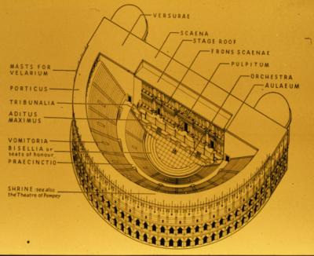 B. 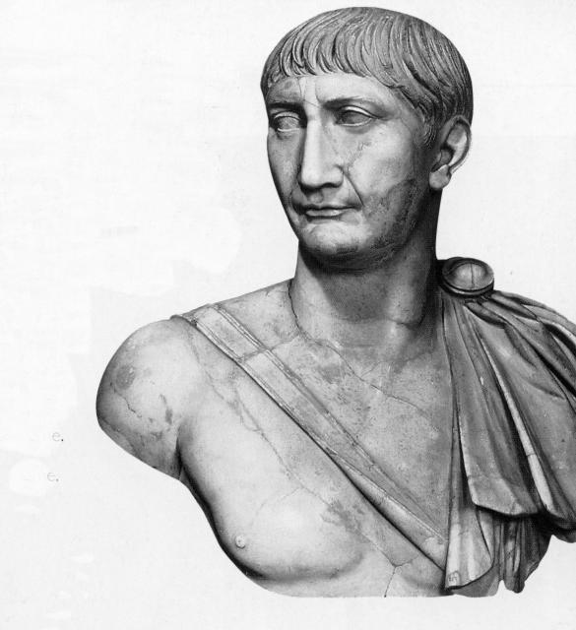 ROUND 1

i.

ii.

iii.
C. 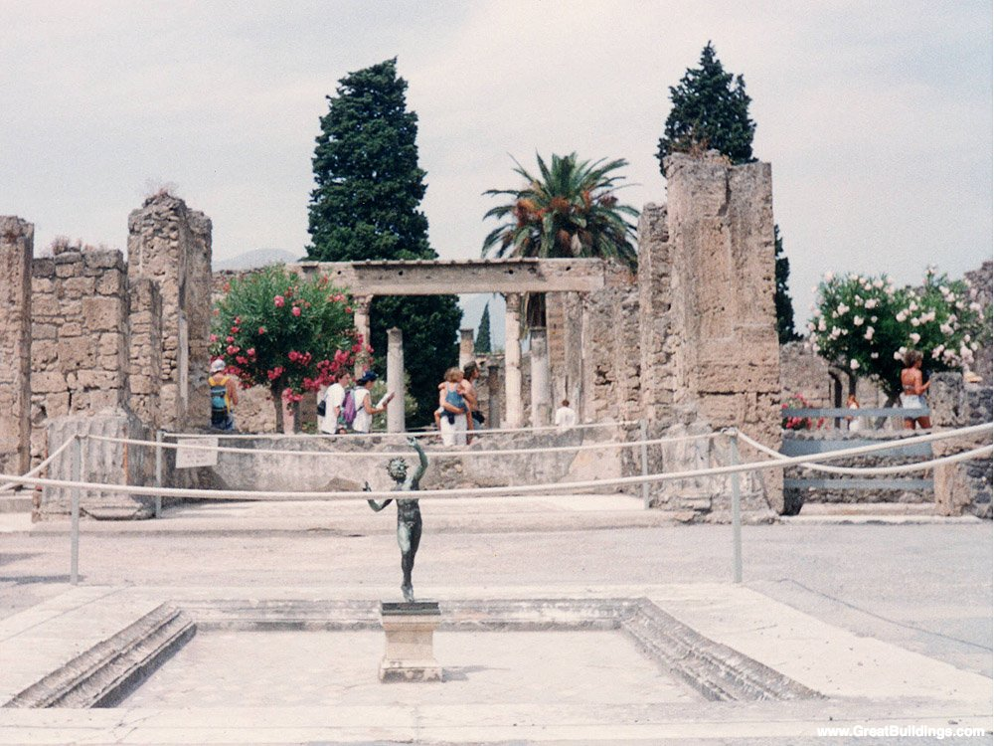 D. 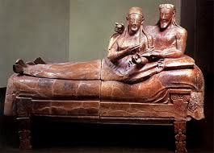
E. 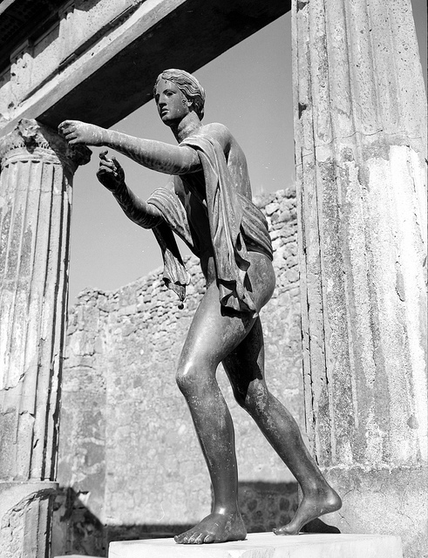 F. 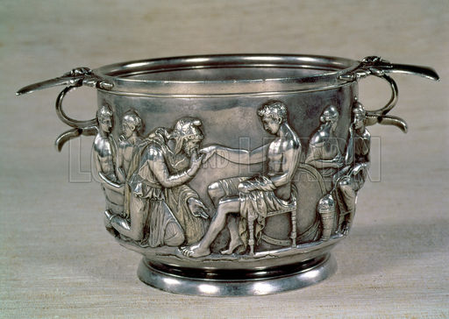
G. 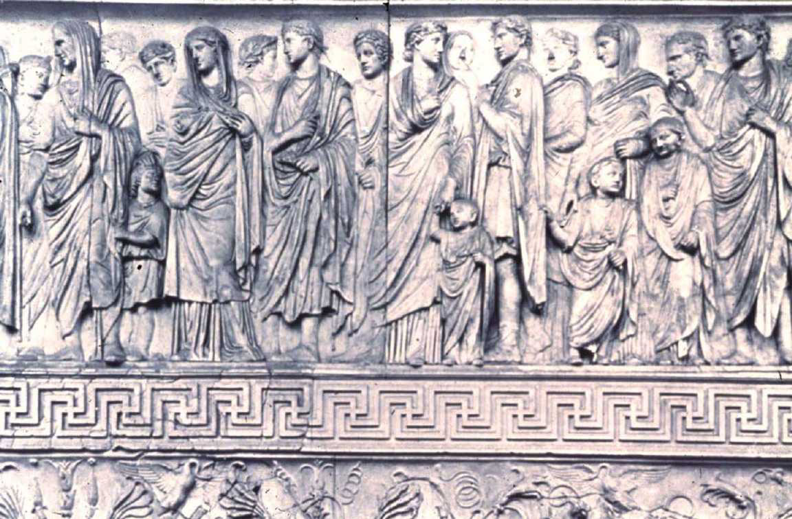 H. 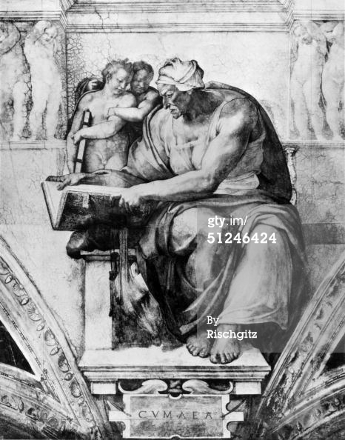
Worksheet Round 1

Team: ________________________ Level: ____________________________

Answer all of the following questions by referring to the accompanying visual worksheet. There is no penalty for wrong answers. Each correct answer is worth 5 points. Misspelled answers may still be counted as correct, but the legitimacy of the misspelled response is up to the discretion of the moderator.

1. In diagram A, give the Latin for the part of the Roman theater labeled i. ____________________________
2. In diagram A, give the Latin for the part of the Roman theater labeled ii. ____________________________
3. In diagram A, give the Latin for the part of the Roman theater labeled iii. ____________________________
4. The bust of which emperor is represented in picture B? __________________________________________
5. Based on the name of the house, what is the dancing figure in the foreground of picture C? ______________
6. The reclining couple that is shown in picture D is typical of which culture’s representation of its people? _______________________________
7. What is the object which is adorned by that reclining couple? ____________________________
8. Who is represented in the statue in picture E? _________________________
9. Where is this statue (and the temple with which it is associated) located? _________________________
10-11. What two men are depicted on this silver and gold drinking cup (picture F)? _________________________ and ___________________________ (5 pts. for each)
12. On what monument is this relief in picture G found (Latin or English is acceptable)? __________________
13. Which figure in this relief is Agrippa? i ii iii iv
14. Identify the large figure in the painting shown in picture H. _______________________________
15. Where is this painting located (be as specific as possible)? ______________________________

To be completed by the moderator:
TOTAL CORRECT RESPONSES: __________
X 5 points
TOTAL POINTS EARNED = _________

A. 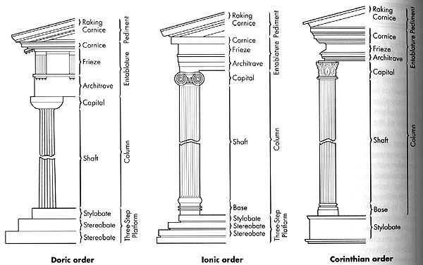 B. 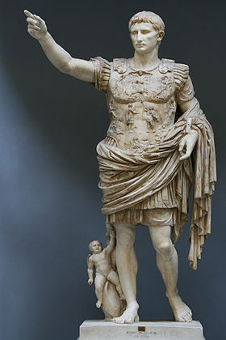

C. 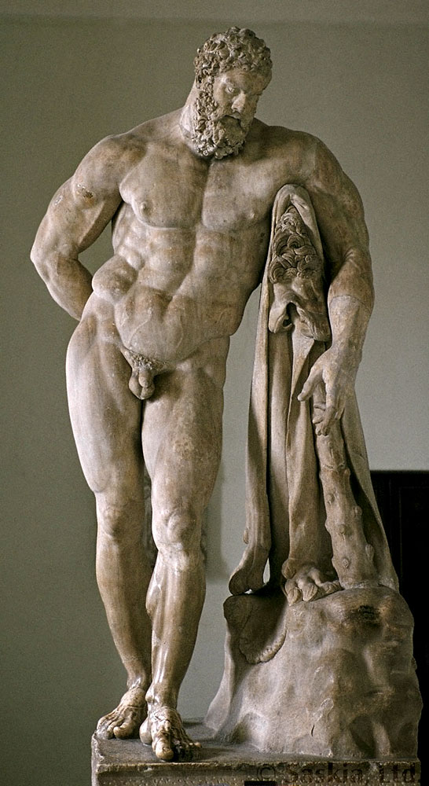 D. 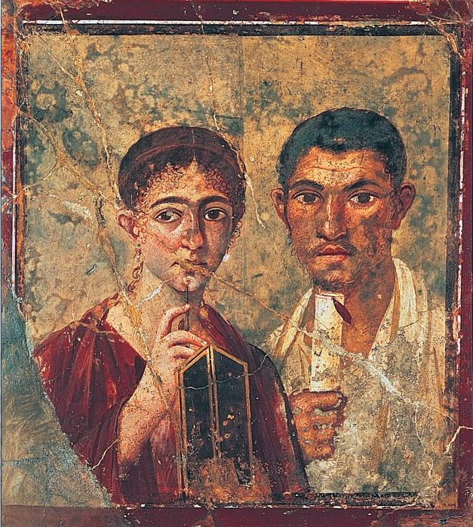E. 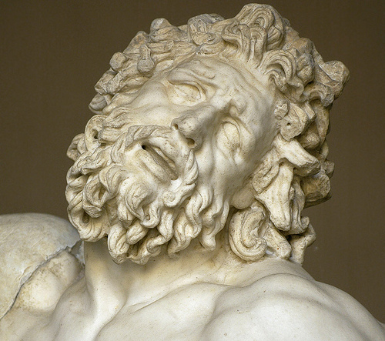

F. 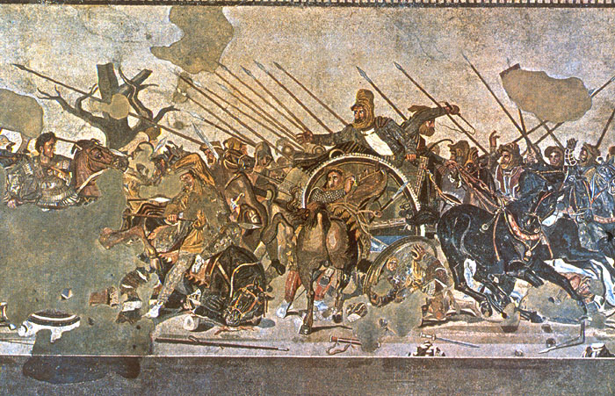 G. 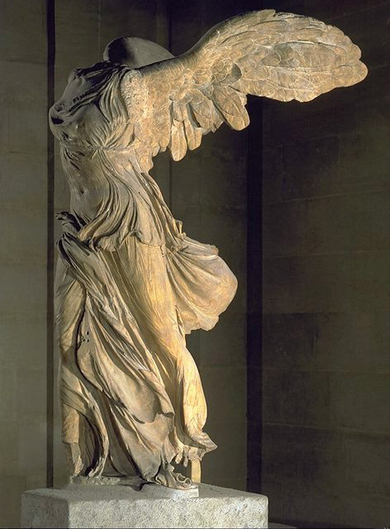 ROUND 2

Worksheet Round 2

Team: ________________________ Level: ____________________________

Answer all of the following questions by referring to the accompanying visual worksheet. There is no penalty for wrong answers. Each correct answer is worth 5 points. Misspelled answers may still be counted as correct, but the legitimacy of the misspelled response is up to the discretion of the moderator.

1. Which Greek order of columns is depicted by the diagram in the middle of picture A? __________________
2. In picture A, which architectural element is labeled “i”? _________________________
3. In picture A, which architectural element is labeled “ii”? _________________________
4. In picture A, which architectural element is labeled “iii”? _________________________
5. Give the common name of the statue of Augustus in picture B (also the location in which it was found). __________________________________________
6. Who is the figure at Augustus’ feet in the statue from picture B? __________________________________
7. Who is the figure depicted in the statue from picture C? _________________________________________
8. What is this person holding behind him in one hand? ____________________________________________
9. The picture of a husband and wife in picture D can be dated to which century (include BC/AD)? __________
10. Name the style of painting represented by the husband and wife in picture D. __________________
11. Which epic character is depicted in picture E? _______________________________
12. Name any of the three artists Pliny the Elder attributes to the sculpture group from picture E.
_________________________________
13. In picture F, who is the man identified by “i”? ___________________________
14. In picture F, who is the man identified by “ii”? ___________________________
15. Although you can now see this on display in Louvre, where (judging by the full name of the work) was this “Winged Victory” originally found? _____________________________
To be completed by the moderator:

TOTAL CORRECT RESPONSES: __________
X 5 points
TOTAL POINTS EARNED = _________
A. 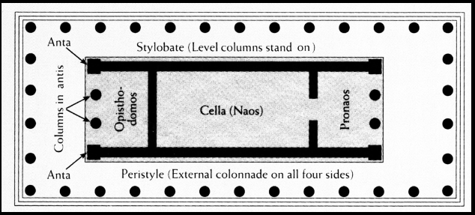 B. 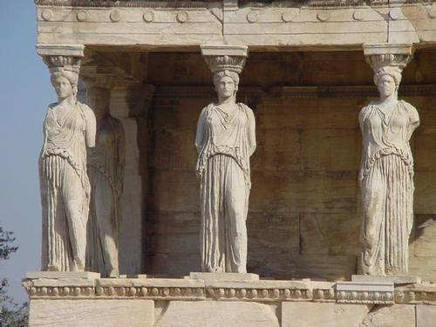
i

C. 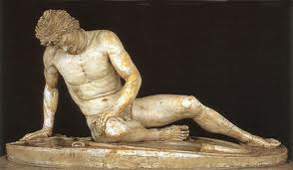 D. 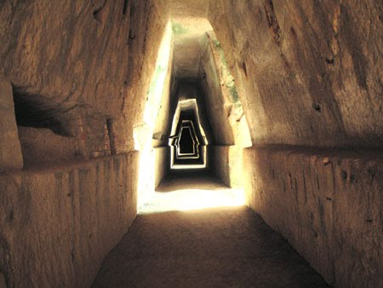
E. 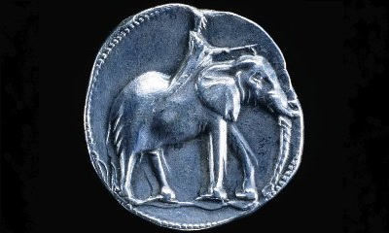 F. 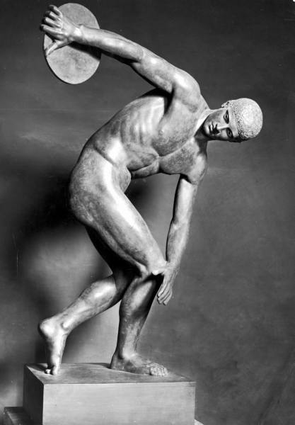 ROUND 3
G. 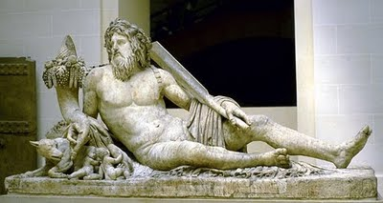 H. 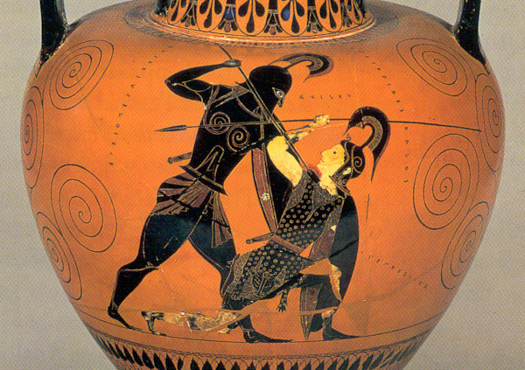

Worksheet Round 3

Team: ________________________ Level: ____________________________

Answer all of the following questions by referring to the accompanying visual worksheet. There is no penalty for wrong answers. Each correct answer is worth 5 points. Misspelled answers may still be counted as correct, but the legitimacy of the misspelled response is up to the discretion of the moderator.

1. Referring to picture A, give the Latin name for the area of a standard Greco-Roman temple labeled “i”.
_______________________________
2. Again referring to A, give the Latin name for the four-sided external colonnade. _____________________
3. What are the figures that both decorate and support a temple called (picture B)? ______________________
4. Which temple on the Athenian Acropolis is depicted in picture B? ________________________________
5. What nationality is the wounded and dying soldier sculpted in picture C? _______________________
6. In which city would one find the monumental entrance from picture D? ___________________________
7. Whose priestess inhabited the shrine seen in picture D? ____________________________
8. Who is depicted on the coin in picture E? ___________________________
9. Give the Latin or Greek name commonly associated with this statue (F). _______________________
10. Who sculpted the statue found in picture F? _________________________
11. Which river is personified in the statue seen in picture G? ______________________
12. In which museums is this statue (G) located today? __________________________
13-14. Name the two characters depicted in picture H.
_________________________ and _________________________ (5 pts. each)
15. What style of vase-painting is represented in picture H? ___________________________

To be completed by the moderator:

TOTAL CORRECT RESPONSES: __________
X 5 points
TOTAL POINTS EARNED = _________

A. 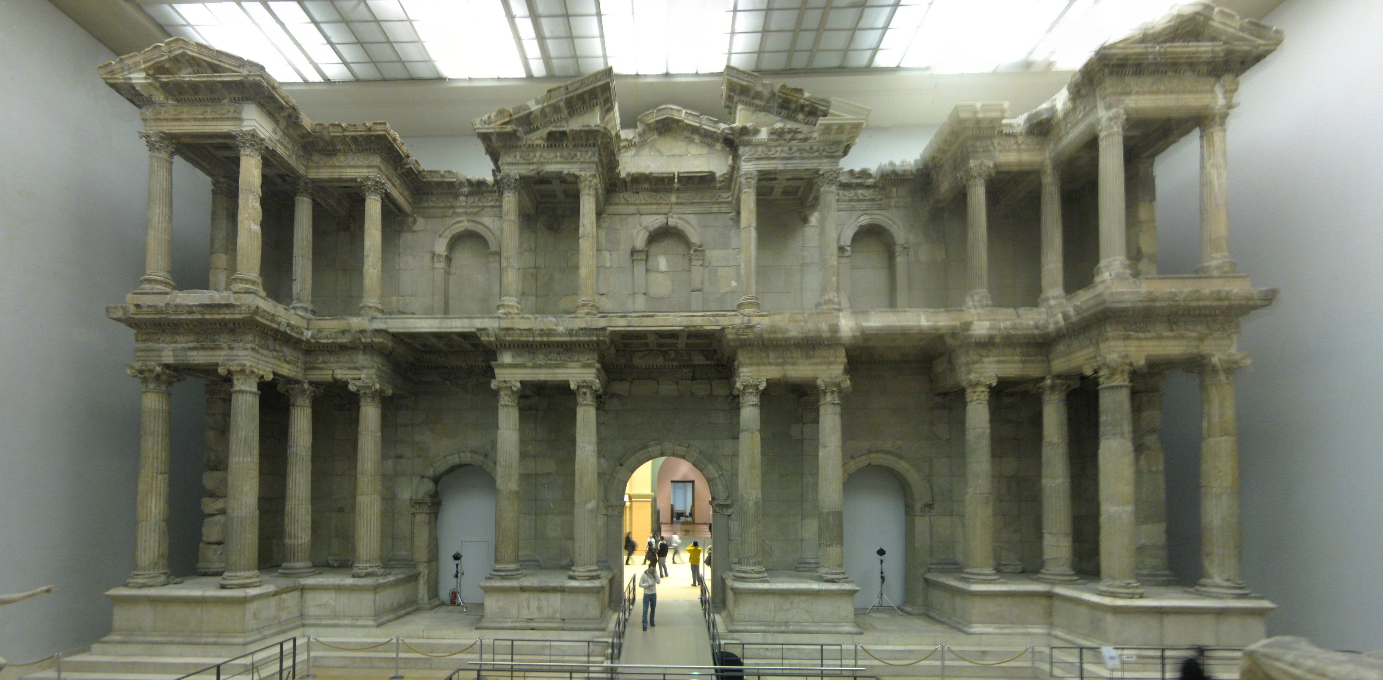 ROUND 4

B. 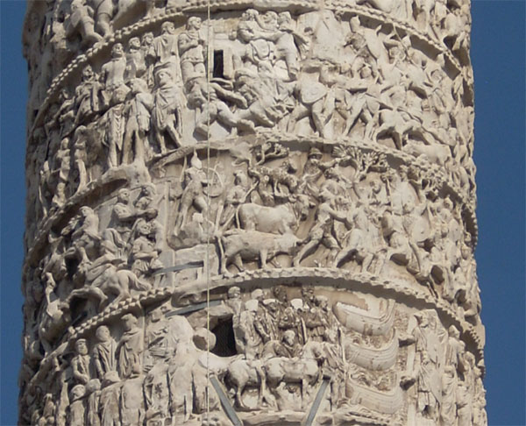 C. 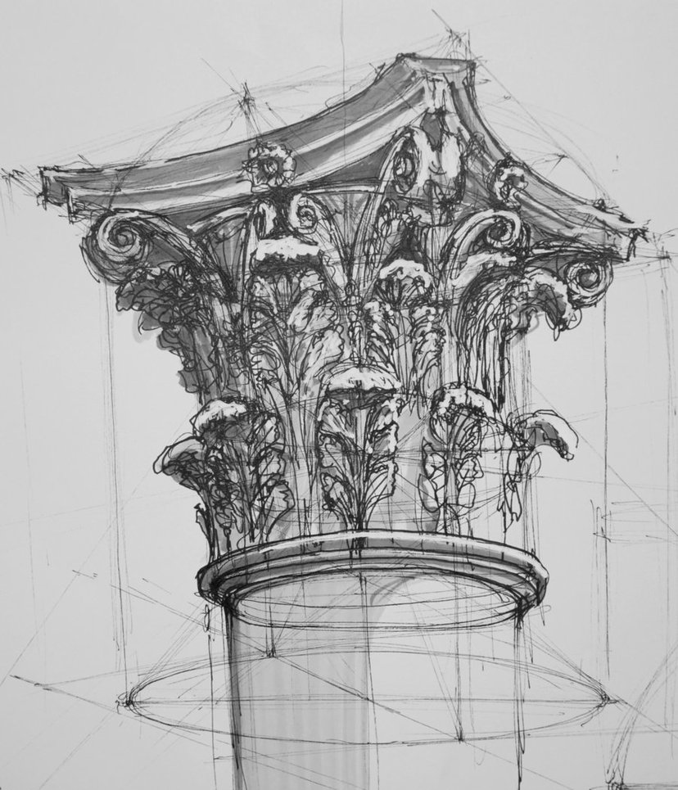

D. 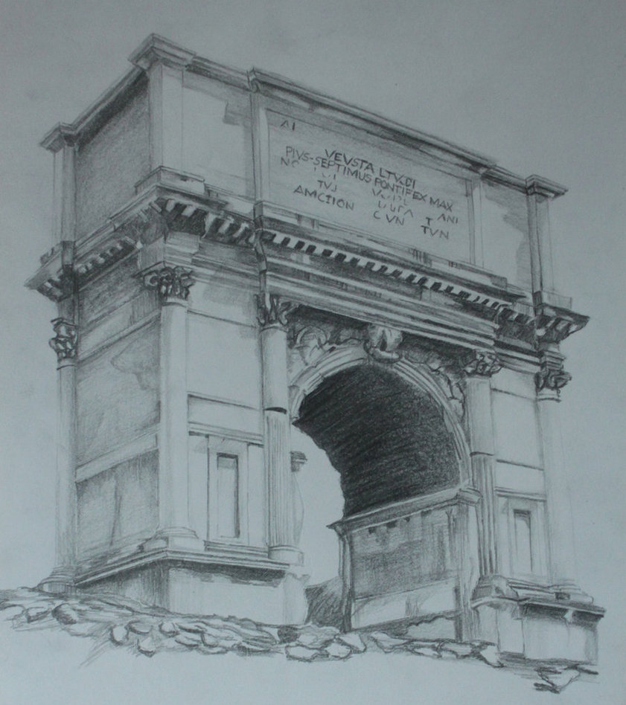

Worksheet Round 4

Team: ________________________ Level: ____________________________

Answer the following questions by referring to the accompanying visual worksheet. There is no penalty for wrong answers. Each correct answer is worth 5 points. Misspelled answers may still be counted as correct, but the legitimacy of the misspelled response is up to the discretion of the moderator.

1. Where was the monumental gate seen in picture A originally located? _________________________
2. Whose column includes a gigantic frieze course running its entire length depicts, among other scenes, his soldiers battling at the Danube River (picture B)? _____________________________
3. What earlier emperor also commissioned a column commemorating his victory over the Dacians? ________________________
4. The leaves of what flower decorate columnar capitals such as in picture C? ________________________
5. Whose arch is shown in picture D? _____________________________
6. The arch in picture D commemorates that emperor’s siege of what city? _________________________
Questions 7-15 do not refer to a picture
7. Give the Latin name for the “eye-hole” in the roof of the Pantheon. ____________________________
8. What is the name of ancient Greek drinking cups with two handles and a stem? ____________________
9. By what name is a typical male archaic statuary figure known? __________________________
10. Which archaeologist discovered the “Golden Mask of Agamemnon”? ______________________________
11. The Temple of __________________ at Ephesus was one of the Seven Wonders of the Ancient World.
12. Give the Latin name for the little tiles which collectively made up mosaics, such as those seen in Pompeii. _________________________________
13. The “________________ Marbles,” so named after the man who bought them, were taken from Greece and are now on display in the British Museum.
14. What animal is usually seen in statues of Mithras? _____________________________
15. Unreal details and too-thin columns characterize the ________________ style of Pompeian wall paintings.
To be completed by the moderator:
TOTAL CORRECT RESPONSES: __________
X 5 points
TOTAL POINTS EARNED = _________
Worksheet Round 1 KEY

Team: KEY

Answer all of the following questions by referring to the accompanying visual worksheet. There is no penalty for wrong answers. Each correct answer is worth 5 points. Misspelled answers may still be counted as correct, but the legitimacy of the misspelled response is up to the discretion of the moderator.

1. In diagram A, give the Latin for the part of the Roman theater labeled i. _____SCAENA FRONS_____
2. In diagram A, give the Latin for the part of the Roman theater labeled ii. _____ORCHESTRA________
3. In diagram A, give the Latin for the part of the Roman theater labeled iii. _____CAVEA__________
4. The bust of which emperor is represented in picture B? ____TRAJAN____________________
5. Based on the name of the house, what is the dancing figure in the foreground of picture C? __FAUN___
6. The reclining couple that is shown in picture D is typical of which culture’s representation of its people? ______ETRUSCAN________
7. What is the object which is adorned by that reclining couple? ___SARCOPHAGUS______
8. Who is represented in the statue in picture E? ____APOLLO________
9. Where is this statue (and the temple with which it is associated) located? __POMPEII________
10-11. What two men are depicted on this silver and gold drinking cup (picture F)? ___PRIAM__________ and ______ACHILLES_______ (5 pts. for each)
12. On what monument is this relief in picture G found (Latin or English is acceptable)?
ARA PACIS/ALTAR OF PEACE
13. Which figure in this relief is Agrippa? i
14. Identify the large figure in the painting shown in picture H. _Cumaean SIBYL___________
15. Where is this painting located (be as specific as possible)? ___SISTINE CHAPEL________

To be completed by the moderator:
TOTAL CORRECT RESPONSES: __________
X 5 points
TOTAL POINTS EARNED = _________
Worksheet Round 2 KEY

Team: KEY Level: __KEY__________________________

Answer all of the following questions by referring to the accompanying visual worksheet. There is no penalty for wrong answers. Each correct answer is worth 5 points. Misspelled answers may still be counted as correct, but the legitimacy of the misspelled response is up to the discretion of the moderator.

1. Which Greek order of columns is depicted by the diagram in the middle of picture A? __IONIC___
2. In picture A, which architectural element is labeled “i”? ___STYLOBATE______
3. In picture A, which architectural element is labeled “ii”? ___ENTABLATURE________
4. In picture A, which architectural element is labeled “iii”? ___ARCHITRAVE_______
5. Give the common name of the statue of Augustus in picture B (also the location in which it was found). _____PRIMA PORTA___________________
6. Who is the figure at Augustus’ feet in the statue from picture B? ___CUPID/AMOR (do not accept Eros)
7. Who is the figure depicted in the statue from picture C? ____HERCULES/HERAKLES___________
8. What is this person holding behind him in one hand? ___Golden APPLES of the Hesperides__
9. The picture of a husband and wife in picture D can be dated to which century (include BC/AD)? _1st AD_
10. Name the style of painting represented by the husband and wife in picture D. __THIRD/ III_____
11. Which epic character is depicted in picture E? __LAOCOON________
12. Name any of the three artists Pliny the Elder attributes to the sculpture group from picture E.
__AGESANDER, ATHENODORUS, POLYDORUS
13. In picture F, who is the man identified by “i”? ___ALEXANDER THE GREAT_______
14. In picture F, who is the man identified by “ii”? ___DARIUS (III)________
15. Although you can now see this on display in Louvre, where (judging by the full name of the work) was this “Winged Victory” originally found? ___SAMOTHRACE__________
To be completed by the moderator:

TOTAL CORRECT RESPONSES: __________
X 5 points
TOTAL POINTS EARNED = _________
Worksheet Round 3 KEY

Team: _____KEY___________ Level: ___KEY______________

Answer all of the following questions by referring to the accompanying visual worksheet. There is no penalty for wrong answers. Each correct answer is worth 5 points. Misspelled answers may still be counted as correct, but the legitimacy of the misspelled response is up to the discretion of the moderator.

1. Referring to picture A, give the Latin name for the area of a standard Greco-Roman temple labeled “i”.
______CELLA____________
2. Again referring to A, give the Latin name for the four-sided external colonnade. __PERISTYLE___
3. What are the figures that both decorate and support a temple called (picture B)? __CARYATIDS____
4. Which temple on the Athenian Acropolis is depicted in picture B? ___ERECHTHEION__________
5. What nationality is the wounded and dying soldier sculpted in picture C? __GAUL____
6. In which city would one find the monumental entrance from picture D? __CUMAE____________
7. Whose priestess inhabited the shrine seen in picture D? ___APOLLO___________
8. Who is depicted on the coin in picture E? ___HANNIBAL__________
9. Give the Latin or Greek name commonly associated with this statue (F). _DISCOBOLUS/DISKOBOLOS__
10. Who sculpted the statue found in picture F? ____MYRON__________
11. Which river is personified in the statue seen in picture G? ___TIBER_______
12. In which museum is this statue (G) located today? ___LOUVRE_________
13-14. Name the two characters depicted in picture H.
_____ACHILLES______ and ____PENTHESILEA____ (5 pts. each)
15. What style of vase-painting is represented in picture H? __BLACK FIGURE_______

To be completed by the moderator:

TOTAL CORRECT RESPONSES: __________
X 5 points
TOTAL POINTS EARNED = _________

Worksheet Round 4 KEY

Team: _____KEY_________ Level: _____KEY____________

Answer the following questions by referring to the accompanying visual worksheet. There is no penalty for wrong answers. Each correct answer is worth 5 points. Misspelled answers may still be counted as correct, but the legitimacy of the misspelled response is up to the discretion of the moderator.

1. Where was the monumental gate seen in picture A originally located? ___MILETUS____________
2. Whose column includes a gigantic frieze course running its entire length depicts, among other scenes, his soldiers battling at the Danube River (picture B)? ____MARCUS AURELIUS__________
3. What earlier emperor also commissioned a column commemorating his victory over the Dacians? ______TRAJAN________
4. The leaves of what flower decorate columnar capitals such as in picture C? ___ACANTHUS_______
5. Whose arch is shown in picture D? ___TITUS__________
6. The arch in picture D commemorates that emperor’s siege of what city? ___JERUSALEM_________
Questions 7-15 do not refer to a picture
7. Give the Latin name for the “eye-hole” in the roof of the Pantheon. _____OCULUS____________
8. What is the name of ancient Greek drinking cups with two handles and a stem? __KYLIX_____
9. By what name is a typical male archaic statuary figure known? _____KOUROS____
10. Which archaeologist discovered the “Golden Mask of Agamemnon”? ___SCHLEIMANN________
11. The Temple of _DIANA/ARTEMIS_ at Ephesus was one of the Seven Wonders of the Ancient World.
12. Give the Latin name for the little tiles which collectively made up mosaics, such as those seen in Pompeii. ______TESSERA(E)_______
13. The “___ELGIN___ Marbles,” so named after the man who bought them, were taken from Greece and are now on display in the British Museum.
14. What animal is usually seen in statues of Mithras? _____BULL_________
15. Unreal details and too-thin columns characterize the __FOURTH_____ style of Pompeian wall paintings.
To be completed by the moderator:
TOTAL CORRECT RESPONSES: __________
X 5 points
TOTAL POINTS EARNED = _________

