MAP OF GAUL – BASIC GEOGRAPHY FROM DE BELLO GALLICO CHAPTER 1

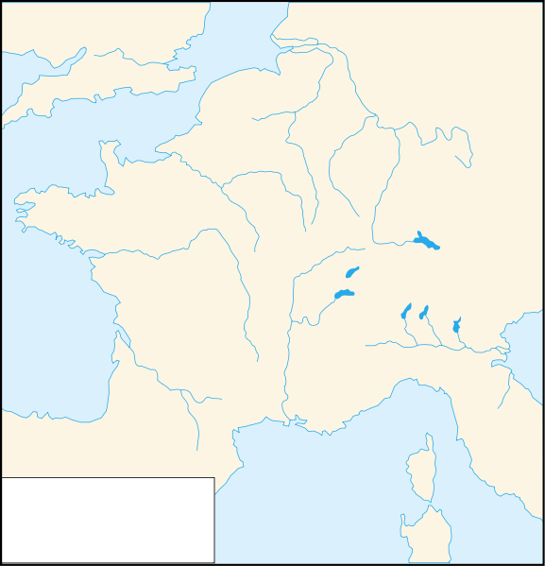

Notes:

MAP OF CAESAR’S TROOP MOVEMENT IN 58

Notes:

MAP OF CAESAR’S TROOP MOVEMENT IN 57

Notes:

MAP OF CAESAR’S TROOP MOVEMENT IN 55

Notes:

MAP OF CAESAR’S TROOP MOVEMENT IN 54

Notes:

MAP OF CAESAR’S TROOP MOVEMENT IN 53/52

Notes:

